Theatre manager
Provides practical and organisational support to the director, actors, designers, stage crew and technicians throughout the production process. They also are the director's representative during performances, making sure that the production runs smoothly. They tell the technicians went to change lights/sound.

Director
In charge of the vision on the performance. They instruct others into how to act, design and run the show.

In charge of learning their lines and creating a clear character. Taking notes from the director and improving that for a public performance.
Stage manager

In charge of the theatre building and the effective running of the theatre.
Technician

Creates the foundation of the play. All ideas stem from this persons original work.
Designer

They oversee the running of the theatre during performances, from welcoming people to taking tickets and serving refreshments.
Playwright

In charge of the look of the play. These people will be involved in different area of the production from lighting, set, sound and costume.
Performer

They are in charge of using equipment that will light the set and bring sound to the performance.
Front of house

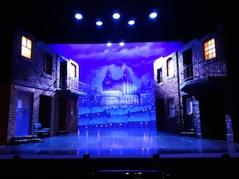
Why has the set been designed like this? What does it tell the audience?

What else could you add to show the class divide in this set design?

Is the set design successful? Explain your answer

Design a costume for Mrs Johnstone and Mrs Lyons (Annotate your designs/State why you have made these decisions. (Link to contrasts)
Mrs Lyons

Mrs Johnstone

What are the themes of the play?

What does the class system mean?

Who are Mickey and Eddie?

Who are Mrs Lyons and Mrs Johnstone?

Who is Linda?

What leads Mickey to killing Edward?

Who are what is to blame for the deaths of Edward and Mickey? Explain your answer

What periods of time is the play set in?
How would you use voice to play Mickey as a child and then as an adult? Explain your decisions

How would you use your voice to play Edward as a child and then as an adult? Explain your decisions

How would you use physicality to play Mickey as a child and as an adult? Explain your decisions

How would you use your physicality to play Edward as a child and as an adult? Explain your answer

